Labwork – 11

Installation of SPARK (Apache)

Downloading SPARK:
Downloading SPARK from https://spark.apache.org/downloads.html Apache Spark official website.

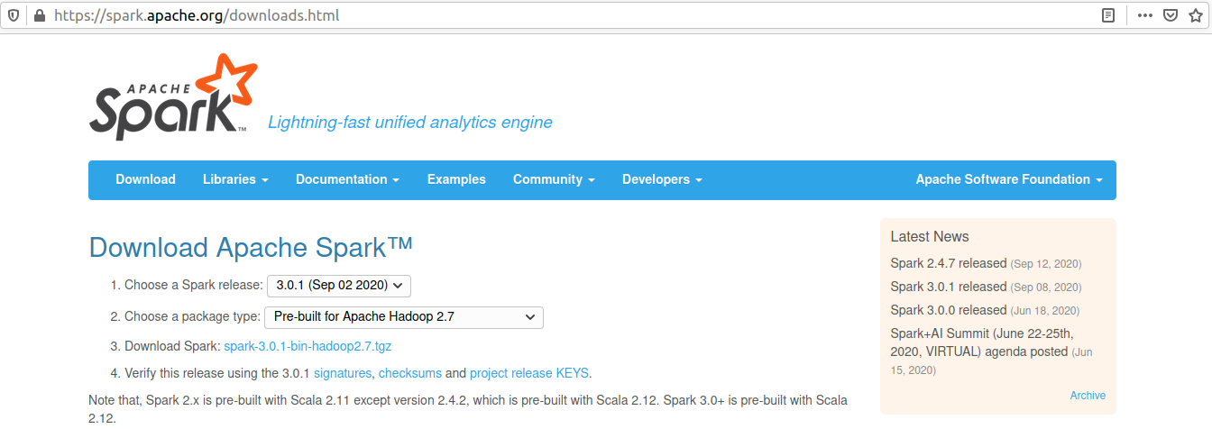
Untar Spark Setup:
Extracting the spark directory using the command tar -xvf spark-3.0.1-bin-hadoop2.7.tgz

Launch the Spark Shell:
Navigating to bin folder in Spark home directory (spark-3.0.1-bin-hadoop2.7) and launching the spark shell using the following command.
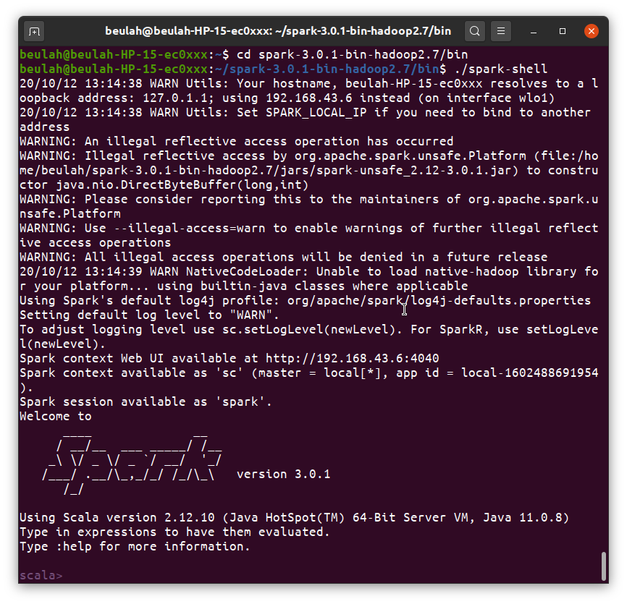
cd spark-3.0.1-bin-hadoop2.7/bin\
./spark-shell

